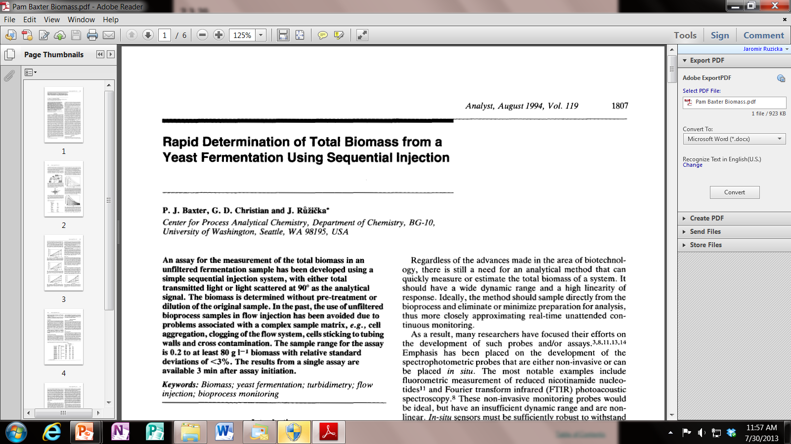 *Analyst, August 1994, Vol. 11 9* **1807**